Session 03 - Introduction to Packet tracer

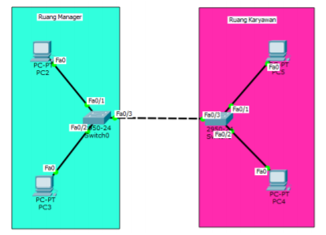

Right now you work as network engineer for PT Ceria Selalu, PT Ceria Selalu expand their work site to Maumere. Make a network plan with requirement as below:

•HRD division: Need 3host

•Security division : Need 9host

NA (Network Address) = 216.239.38.0

SM (Subnet Mask) = 24

= 11111111.11111111.11111111.00000000

= 255.255.255.0 -> class C

* **Security Division**

2^h – 2 >= 9

2^4 – 2 >= 9

16 – 2 >= 9

14 >= 9

h = 4

n = 32 – b – h

= 32 – 24 – 4

= 4

**Subnet Mask baru** = 11111111.11111111.11111111.**1111**0000

= 255.255.255.240

**Network prefix baru** = /28

**Total host** = 2^h

= 2^4

= 16 host

* **HRD Division**

2^h – 2 >= 3

2^3 – 2 >= 3

8 – 2 >= 3

6 >= 3

h = 3

n = 32 – b – h

= 32 – 24 – 3

= 5

**Subnet Mask baru** = 11111111.11111111.11111111.**11111**000

= 255.255.255.248

**Network prefix baru** = /29

**Total host** = 2^h

= 2^3

= 8 host

IP Address Table

|  |  |  |  |
| --- | --- | --- | --- |
| Division | Network Address | Usable IP Address | Broadcast Address |
| Security | 216.239.38.1/28 | 216.239.38.2/28 - 216.239.38.15/28 | 216.239.38.16/28 |
| HRD | 216.239.38.17/29 | 216.239.38.18/29 - 216.239.23./29 | 216.239.38.24/29 |

**Nama PC beserta IP address pada topology:**

Divisi programmer : SA (216.239.38.2), dan SB (216.239.38.3)

Divisi Marketing : MA (216.239.38.18), dan MB (216.239.23.19)

**Topology Menggunakan Packet Tracer**

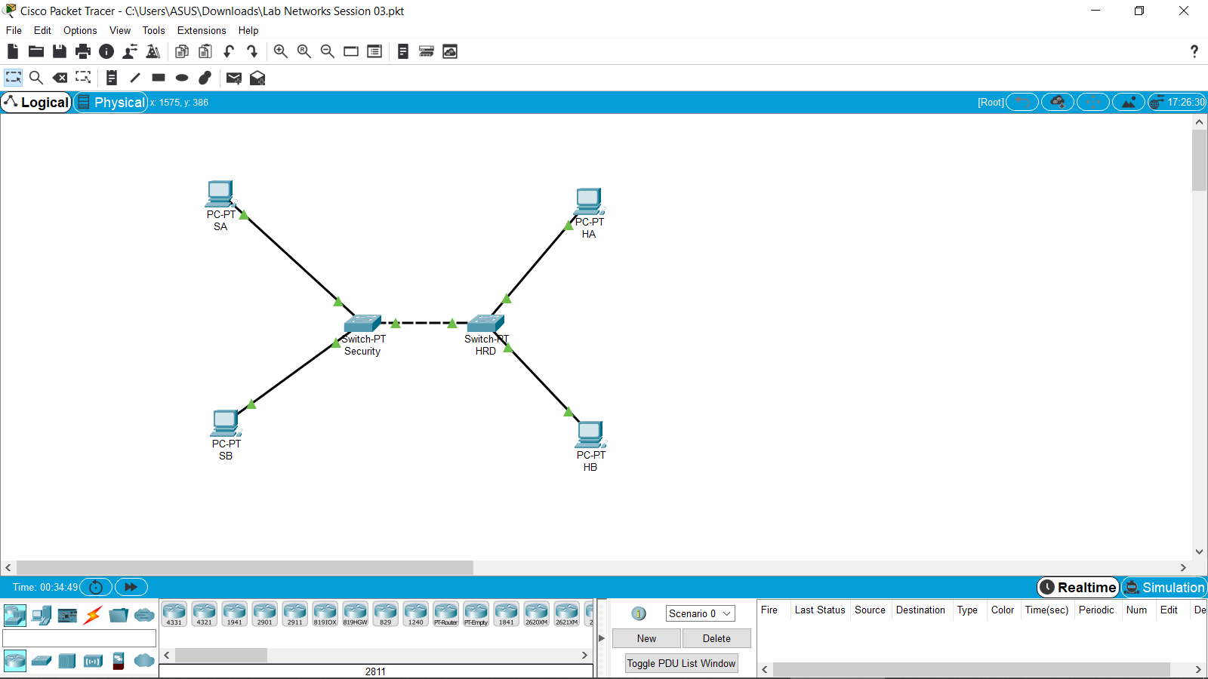

Ping PC SA ke PC SB

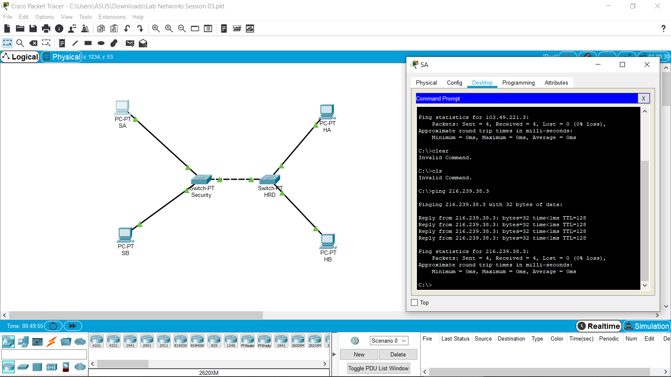

Ping PC SB ke PC SA

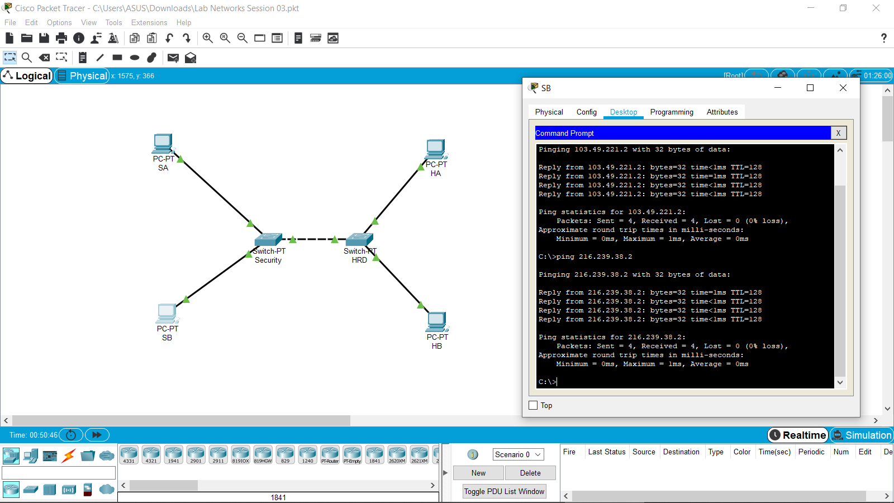

Ping PC HA ke PC HB

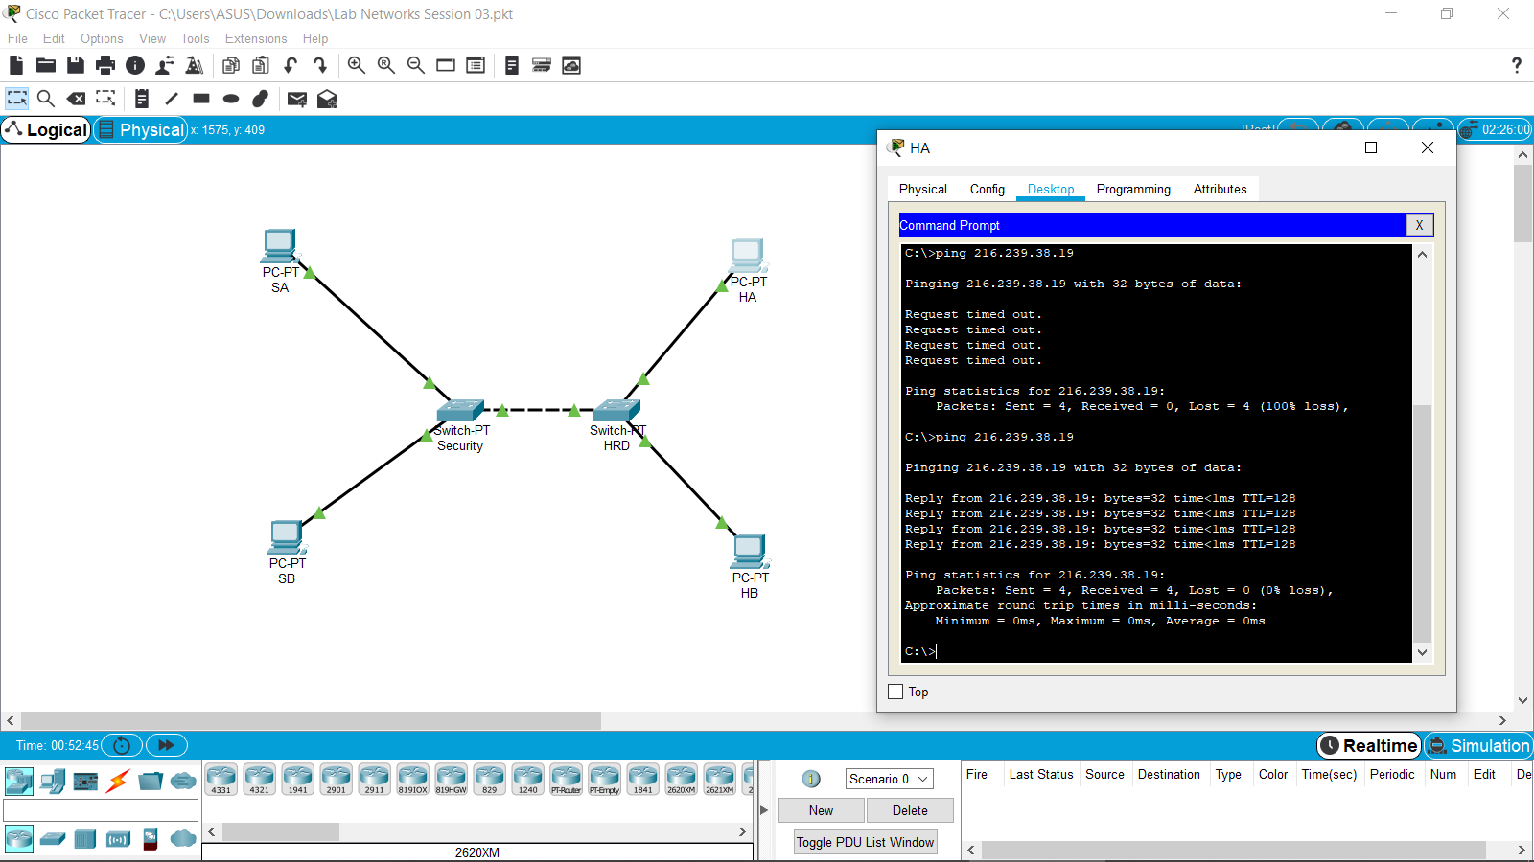

Ping PC HB ke PC HA

